Quick Start Guide To Handle The System
User Manual
How To

By Zulhisham Tan

Content
Page
- HOW TO : Start The System 1
- HOW TO : Initialize The Device 2
- HOW TO : Start An Inspection 3
- HOW TO : Switching Between The Operation Mode 5
- HOW TO : Operate In Manual Mode 6
- HOW TO : Set The Offset For The Tape Rail 7
- HOW TO : Do A Dummy Test Run For Accuracy Monitoring 8
- HOW TO : Access Advance Setting Of The System 10
- HOW TO : Retrieve Lot End Data 12
- HOW TO : Confirm Offset Setting For Tape Rail 13
- Appendix A : Tower Light lighting system 14
- Appendix B : Password 15

HOW TO : Start The System
By default, the application software is set to ‘Auto Startup’ once the computer is successfully booted up. User might experience a Windows as shown in the figure below during the system is booting up. The Windows indicates that the application software is checking for update on the network. The application software will update itself automatically when the application software found any higher version become available on the network. The entire process is done during the Window appears in the computer screen.
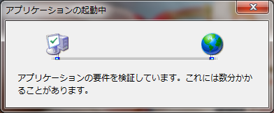

The application splash screen as the following illustration shown up, when the update process completed.
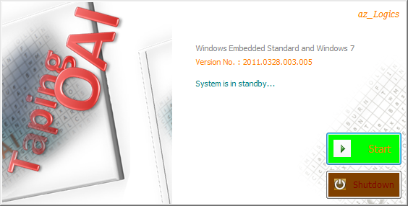

Press the ‘Start’ button to continue the startup process. User can press the ‘Shutdown’ button to terminate the application.

HOW TO : Initialize The Device
The system need to be initialized when the system is first boot up. The initialization process loads the system parameter from the Windows Registry. The entire mechanism will then move to it origin position.
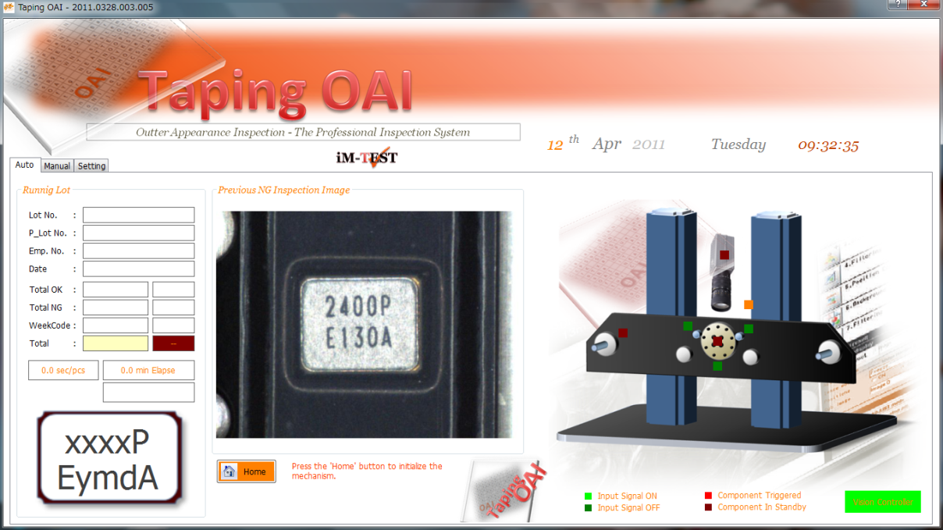

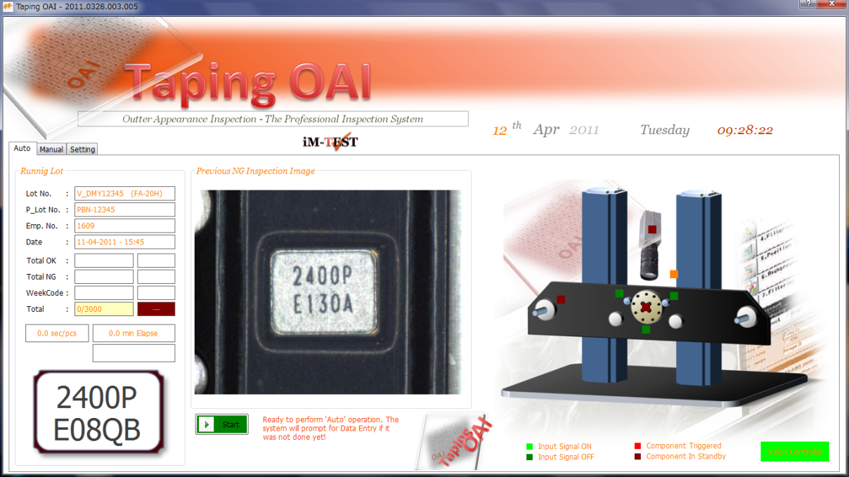
Whenever the system is in the ‘Initialization’ mode, the application software is waiting for ‘Homing’ command as illustrate in the figure above - the command button is labeled ‘Home’. Press the button will start the initialization process. The label of the button will change to ‘Start’ when the initialize process successfully completed.

HOW TO : Start An Inspection

When the system complete it initialization, it is in ‘Auto Ready’ mode as indicated by the “Tower Light” lighting convention (See Appendix A for full description).
To start the ‘Auto’ operation, simply click on the ‘Start’ button at the UI or the ‘Start’ button at the Operational Panel. A series of dialogue box as shown below will appear.
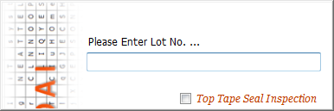
Lot No.
This is the Taping Lot No that appear in the LPR. Use the Barcode Reader to scan the number.

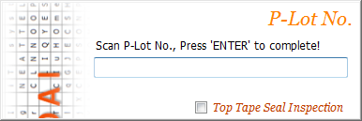
P-Lot No.
This is the mother Lot No which this Lot is formed. The system used these numbers to retrieve marking data from the database. Press the ‘Enter’ key to complete the entry. This step skip for Dummy Run.

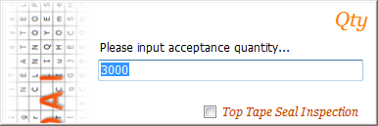
Qty
This is the Taping Lot quantity. It is set to 3000 pieces by default. The system used this number to enter Lot End (Inspection End) mode.

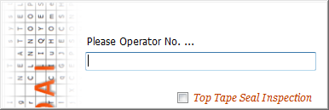
Emp. No.
This is the Employee number. The system records this number in the Lot End Data report.

The system displayed all the entries input by the operator at the ‘Auto’ tab as shown in figure above. Whereas the marking data which retrieved from the marking process network is shown in the layout.
To start the ‘Auto Run’ operation, simply press the ‘Start’ button either at the UI or at the operational panel.

To Be Done :
- The Tape Stopper (Right side & Left side) must at lock position otherwise the system will returns an alert.
- The Safety Cover must be in the closed state. Otherwise an alert is returns.

Remarks :
- During Auto Running mode, the system will automatically switch to ‘Auto Ready’ mode whenever the Safety Cover is opened.
- The system will also get interrupted if either the Tape Stopper is released.
- The inspection will be automatically cancelled if both of the Tape Stopper is being released.
Options :
- Press the ‘Stop’ & ‘Start’ button simultaneously until the buzzer sound is heard in order to manual cancel an inspection.

HOW TO : Switch Between Operation Mode

As highlighted in the figure above, simply click on the Tab to switch between the systems’ operating mode.
The system will prompt for a password to be entered when the ‘Setting’ mode is being selected. Press the ‘ESC’ at the keyboard or the ‘Stop’ button to cancel the selection otherwise enter the password and then hit the enter key. The system will retain at ‘Setting’ mode if the password is being authorized otherwise the system will switch back to the mode before the ‘Setting’ mode is being selected.


HOW TO : Operate In Manual Mode

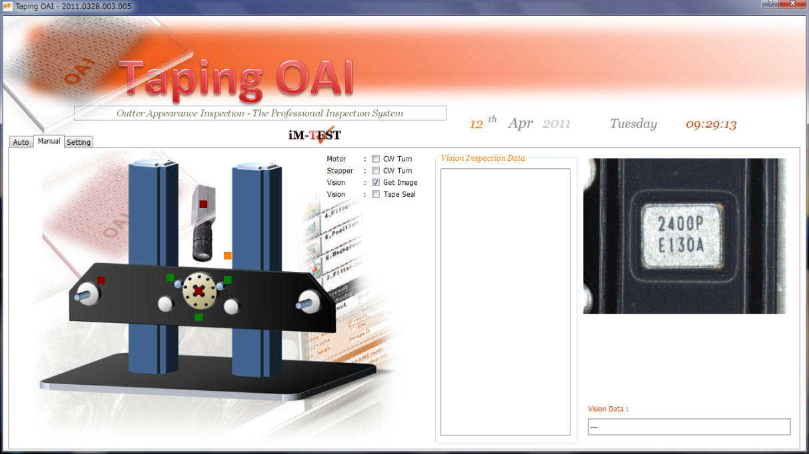
Switching Operational Mode
Click on the ‘Manual’ Tab to switch to ‘Manual’ operation mode.
Trigger The Vision System
Click on the Red Square box to trigger the Camera. The vision image is displayed if the option is turn ON.
Options Selection
Click on the check box in order to trigger ON or trigger OFF a specific option.

Trigger The Tape Rail
Click on the Red Square box will trigger the motor pitch by pitch. Press the ‘Stop’ button and then the ‘Start’ button at the operational panel will have similar effect. To rotate in different direction, simply chose from the optional box.

Trigger The Tape Puller
Continuous click on the Red Square box will trigger the motor. When release the mouse, the motor stop triggering. To rotate in different direction, simply chose from the optional box.

HOW TO : Set The Offset For The Tape Rail

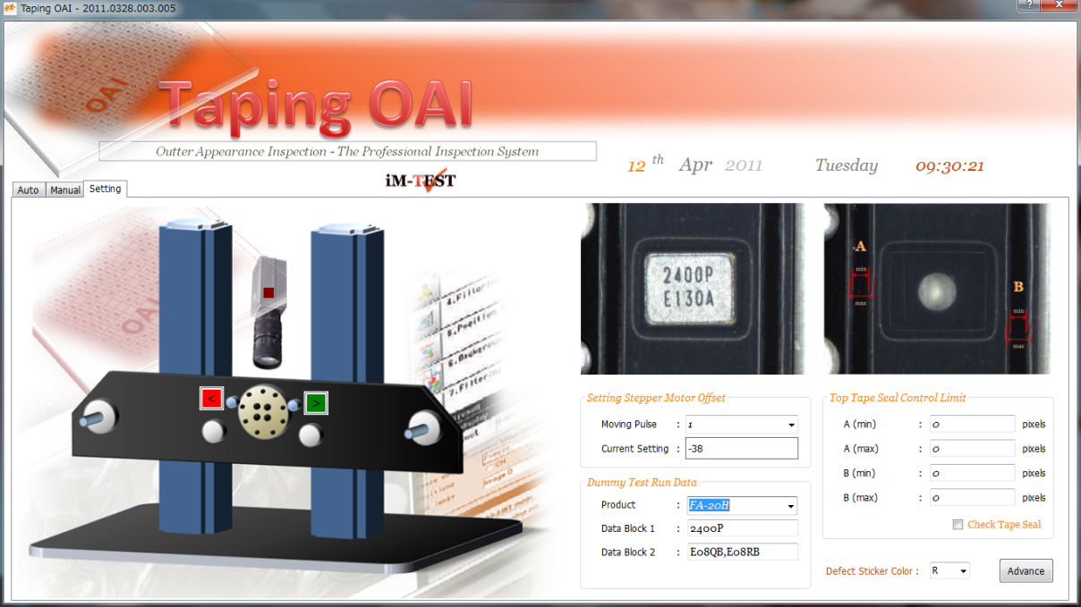
Switching Operational Mode
Click on the ‘Setting’ Tab to switch to ‘Setting’ operation mode.

Current Setting
The current setting is displayed.

Changing The Offset Setting
Click on the buttons will trigger the Tape Rail pulse by pulse where each pulse moves the Tape Rail by 1 degree. The new setting automatically saved to Windows Registry. Optionally, press on the ‘Stop’ & ‘Start’ button at the Operational Panel will have similar effect.

HOW TO : Do A Dummy Test Run

Switching Operational Mode
Click on the ‘Setting’ Tab to switch to ‘Setting’ operation mode.

Entering Dummy Test Run Data

User should select the proper range of product from the Dropdown list. And then key in the appropriate marking data as shown in the figure.

To enter multiple week code of marking data, place a comma (without a space character) after the first data and then continue with the same criteria. Placing any space character will potentially crash the system since TSX week code contains space character.

Advance Setting

If the target product does not exist in the Dropdown list, user can customize it in the Advance Setting procedure.

Switching Operational Mode
Click on the ‘Auto’ Tab to switch back to ‘Auto’ operation mode. And then click on the ‘Start’ button or press the ‘Start’ button at the operational panel.

Lot No.
Key in the Lot No begins with “V_”, the system will access the marking data that entered in the ‘Setting’ mode instead of accessing the Network database.

P-Lot No.
The system will skip this step for Dummy Test Run.

Emp. No.
The system records this number in the Lot End Data report.

Qty
Key the quantity as desired. The system used this number to enter Lot End Mode automatically.

Once the data completely entered, the system is ready for ‘Auto Run’. The behavior of the system during ‘Auto Run’ for Dummy Test is equally same as normal ‘Auto Run’ operation.
HOW TO : Access Advance Setting Of The System

Switching Operational Mode
Click on the ‘Setting’ Tab to switch to ‘Setting’ operation mode.

Accessing Advance System Setting
Click on the ‘Advance’ button to access the advance setting of the system.

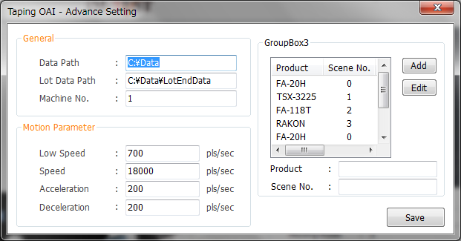
General
Setting for the system Data path.

Motion Parameter
These setting will effects the speed of the Tape Rail movement. Improper setting will cause excessive noise and mechanical error.

Scene Setting
Users are allows to customize the Vision Scene setting according to the product.

HOW TO : Retrieve Lot End Data
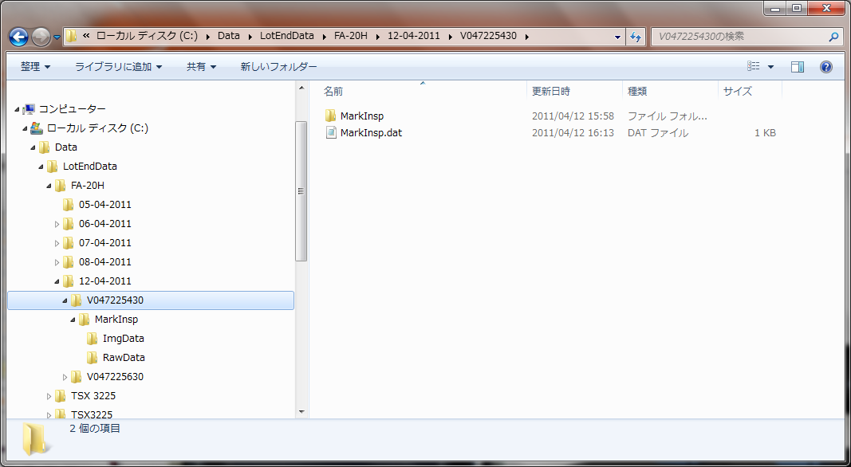
The Lot End Data path is by default located at the “C:\Data\LotEndData”. However, it can be customized, see “HOW TO : Access Advance Setting Of The System” in this manual.
Lot End Data is organized in such a way in which it is based on the product code >> The Date of the inspection being carried out >> And then the Taping Lot No.
Within the specify path, a summarization report can be found for each inspection type (Seal Check or Marking Inspection). It is also divides into the type of inspection. For each type of inspection, the system provides the raw data as well as the NG images.

Remarks :
- The Lot End Summarization report is generated automatically each time the ‘Inspection End’ alert is heard.
- The system used the Quantity Data in which it is being entered during the Lot Data Entry process. The system log itself into ‘Lot End’ Mode when the counting counts up and the system detected empty pocket after the counts up.
- The system will continue 25 inspection of empty pocket after the count up before an alert is heard.
- If the quantity entered is less than the actual quantity, the system will ignore the data and continue the inspection until empty pocket is detected.
- If the quantity entered is more than the actual quantity, the system returns an alert immediately if an empty pocket is detected.

HOW TO : Confirm Offset Setting For Tape Rail

Switching Operational Mode
Click on the ‘Setting’ Tab to switch to ‘Setting’ operation mode.
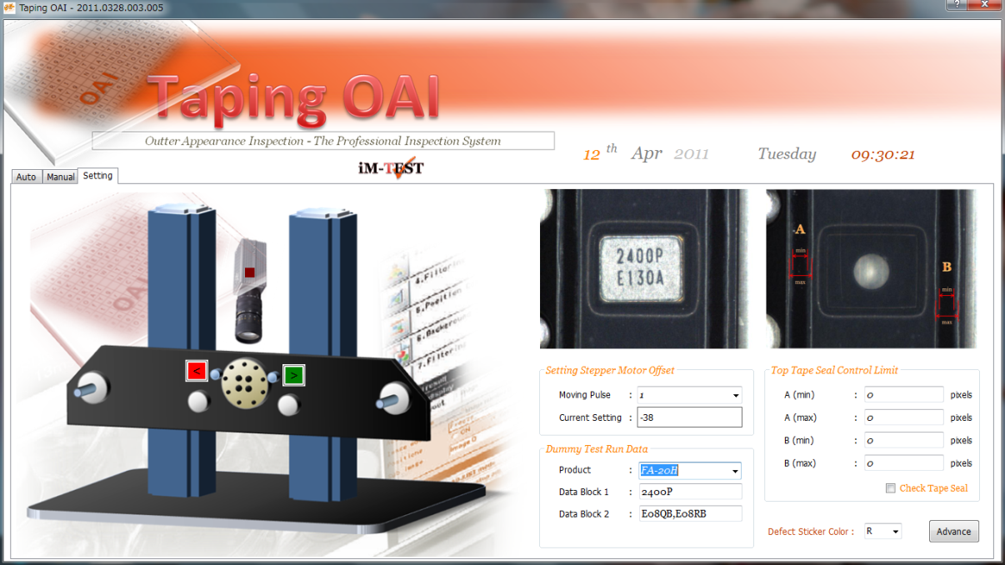
S

Changing The Offset Setting
Click on the buttons will trigger the Tape Rail pulse by pulse where each pulse moves the Tape Rail by 1 degree. The new setting automatically saved to Windows Registry. Optionally, press on the ‘Stop’ & ‘Start’ button at the Operational Panel will have similar effect.

Center of The Image

The offset setting of the Tape Rail is solely depends on the inspection unit is at the center of the image.
Trigger The Vision System To Retrieve Sample Image

Click on the Red square box to trigger the Vision system in order to retrieve a sample image.

Appendix A : Tower Light Lighting System

Tower Light Color | Lit ON | Blinking
RED | System Alarm, Error or Warning | -
Yellow | Auto Running Mode | Auto Mode, Standby Mode  (Ready to perform Auto Running operation)
Green | Manu Mode. Users are allows to freely operate the system mechanism. | -

Appendix B : Password

123

Password

By default, the system password is set to ‘123’.

However, it can be customized under the Windows Registry manually.

